Mess News
19th Dec. 2002



Dear Mess Members,

Please give a big cheer to our new Mess President, Helen Callister, SHO in Cardiology, who was unanimously elected to sit on the hot seat for the next year. A huge thank you to our last President, James Nevison, for all his efforts and support during his time at the helm.

Following the elections, we proceeded to form a new committee with many familiar faces (all medics!) and updated ourselves on progress and new developments.

MESS SERVICES

We hope you have enjoyed our new selection of coffee, tea and hot chocolate together with lolly pops, biscuits and pic ‘n mix. These are now made available every Friday to catch the weekend on-callers until they run out so don’t waste ‘em!


Our PC is out for essential repairs at the moment but should be back soon. There is, we are told, definite internet access. Note that inappropriate use could result in permanent loss of connection- you’ve been warned!

The mini-size pool table is still out at the General. Liz Lewis, Residency manager, is however on the case. We are informed she has taken necessary measurements and will shortly arrange for transport. We will provide new cues when we get the table.

Liz has also made available a brand new toaster. Those who knew the old one intimately will realise we have now been freed from one sided toast! Yippee!

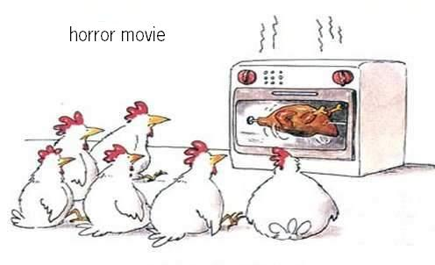
Our Sky Dish is still back in the old mess. The works department will kindly reinstall it at our new premises on the 30th of December.

We need a sound system to get some music into the mess. A juke box system is just too pricy for our budget hence we are getting a state of the art multi cd hi-fi player and will aim to provide a collection of favourite cd’s for members to play.

We thought our new mess could do with a personal touch by getting some pictures and photo collages up on the walls. If you want your pic up there get in touch with Helen (bleep 4474) asap.

A website is about to be born thanks to our designer James. If you want anything up on the web, accessible via the postgrad dept web page on the intranet, then get in touch with Evin (bleep 1455).

We have realised how inconvenient it is to have only one phone for the mess given its large size. We are going to approach the IT dept regarding an extension and second phone. Will keep you posted!

Our drinks machine has apparently gone missing! Anyone know where it is? We have asked to have it back and are hopeful this will happen soon. Sorry for the inconvenience….


Finally, we have received a number of quotes for a magnetic swipe card lock. It looks like its going to happen but not for a few weeks as we have to get through all the red tape first. This will provide more security and a fairer approach to who uses those extra facilities the mess offers to its paying members.

Our newspaper service is now happening on a regular basis. We just need to get reception used to getting the papers to the mess promptly. We thank the security officers for their kind help in this respect although feel the pain of paying £35 a month for the service…

We hope we will have all these things ready by the time our new take comes in February. Bisher says he is going to prepare a leaflet to promote our mess. Look forward to it, Bisher!

MESS EVENTS

Mess Party- Friday 31st January- to celebrate our new mess opening and say goodbye to those who are leaving in February. All welcome, including guests! There will be music (alcohol!), food and good chat, all for a modest entry ticket sum, shortly on sale near you!

Further nights out info will follow.

Our next meeting will be at 5 pm on Monday 13th January. Please let us know any suggestions or complaints and if you are curious, come along to the meeting too!

The Mess Committee

Brendan McCarron, Mess Rector
Helen Callister, Mess President
Bisher Kawar, Vice President
Ed Chan, Social Sec
Fiona McGill, Treasurer
James Nevison, Charities Sec
Evin Sowden, Membership Sec (Editor)

