SOCIAL EVENTS
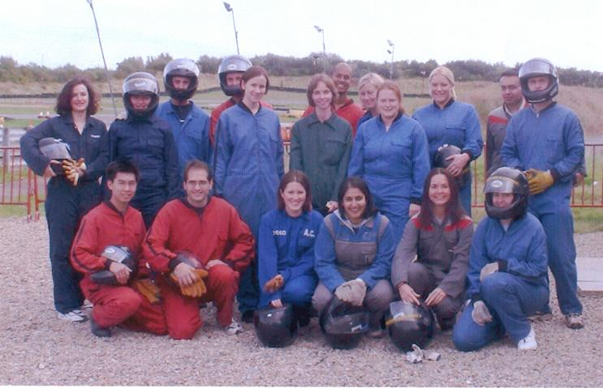
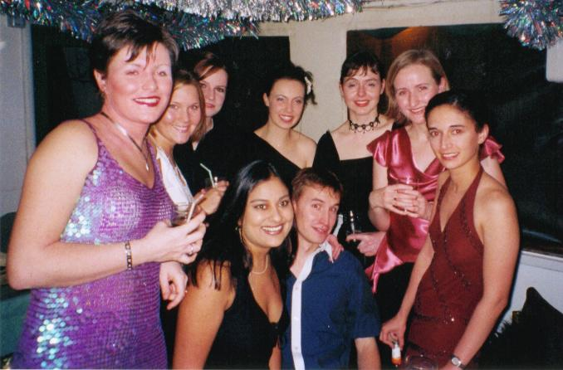
Throughout the year the Mess Committee organize several events for members. In 2002 there was the inaugural Mess Go Karting challenge and this will be repeated in 2003. We also held a Christmas Cruise along the River Tees on board the Teesside Princess. There is a full Christmas Dinner and free bar!! In the summer we have a Formal Ball and throughout the year we host various charity events such as Ceilidhs and Wine Tasting!! At the end of every month we organize the Mess Social a must for all junior doctors!!



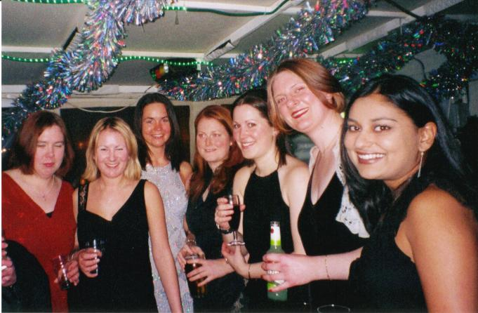

Welcome to the Doctors Mess!
As a Junior Doctor working at The James Cook University Hospital you are entitled to be a member of the Junior Doctors Mess. The Doctors Mess is funded and run by Junior Doctors working in the trust and works to improve both the on call facilities and the social side of your job.


Doctors mess
Our facilities are situated in the new part of the Hospital and opened in December 2002. The Mess has different areas including a bar, lounge area, quiet study room and kitchen. The rooms are situated centrally in the hospital and so are equally accessible for doctors in all specialties.
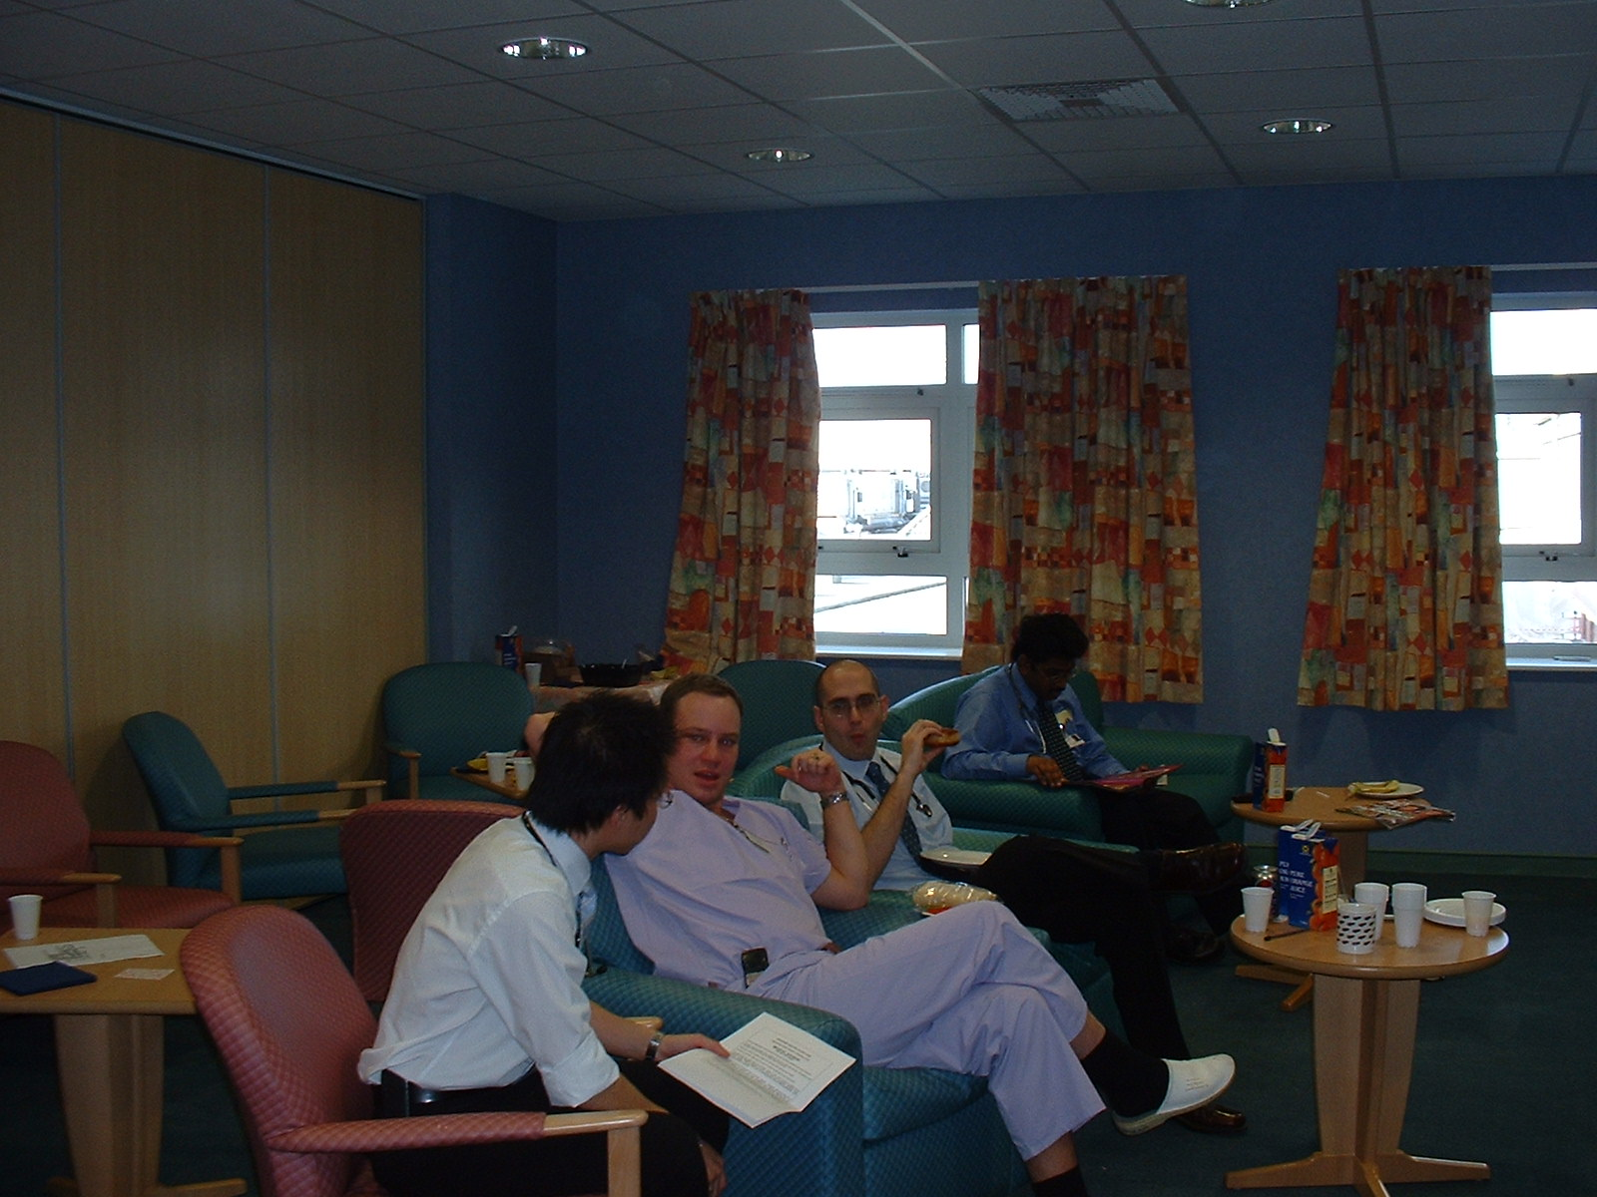
Doctors enjoying the mess lounge room

Mess bar
The bar area is used throughout the day as a recreational area as it provides a pool table, music center, playstation and snack machines. After normal working hours it provides a free bar and plenty of room to socialize with your colleagues.
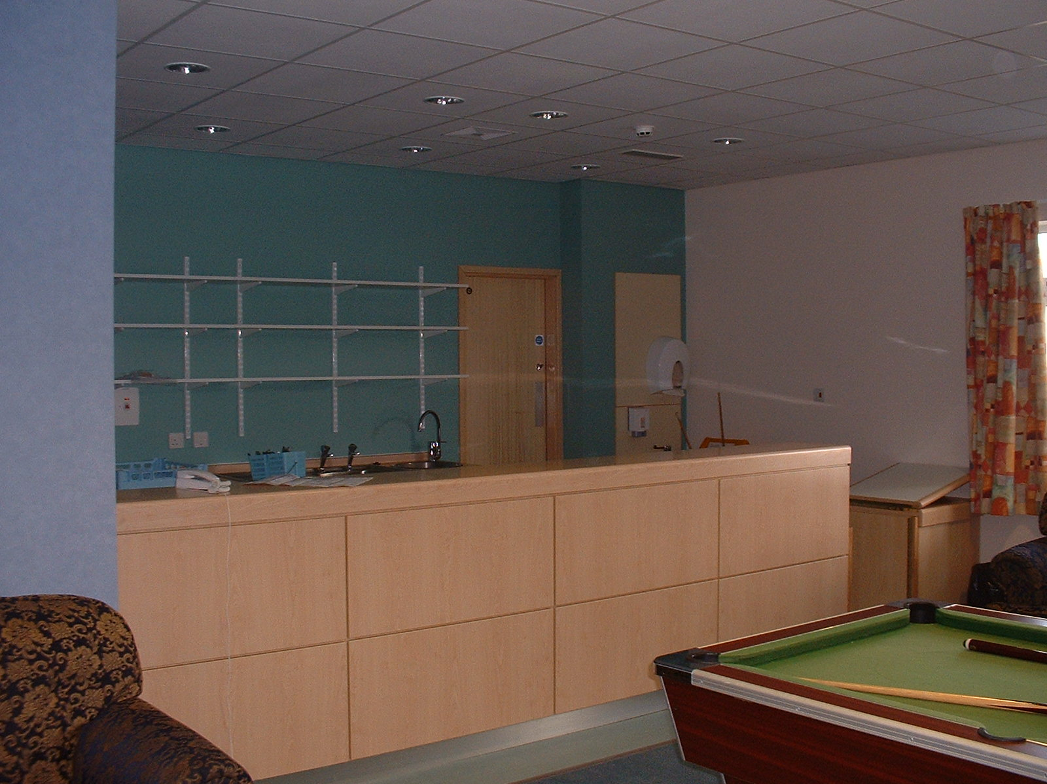

THE KITCHEN
The kitchen area provides everything you might need throughout the day. Aside from a refrigerator, two microwaves and a boiler we also provide a percolator for fresh coffee, fresh herbal teas and hot chocolate.
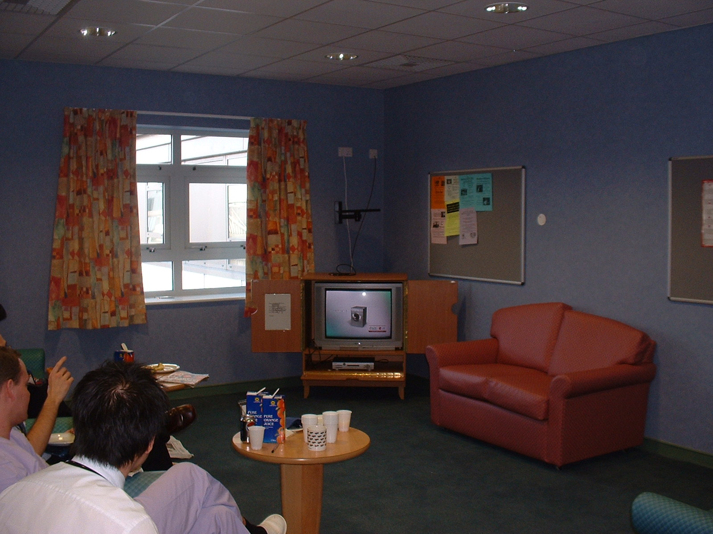

LOUNGE AREA
The main attraction in the lounge area is the huge television with full Sky package. There are plenty of chairs and tables around for you to eat your on call meal or sample a cup of fresh coffee with friends. Every Wednesday we hold a free lunch provided by one of the regional Drug Representatives.

